CS 255 System Design Document Template

UML Diagrams

UML Use Case Diagram
The following UML use case diagram identifies the major people and outside systems that interact with DriverPass. It includes customers, secretaries, instructors, IT staff, management, the DMV system, and payment processing.
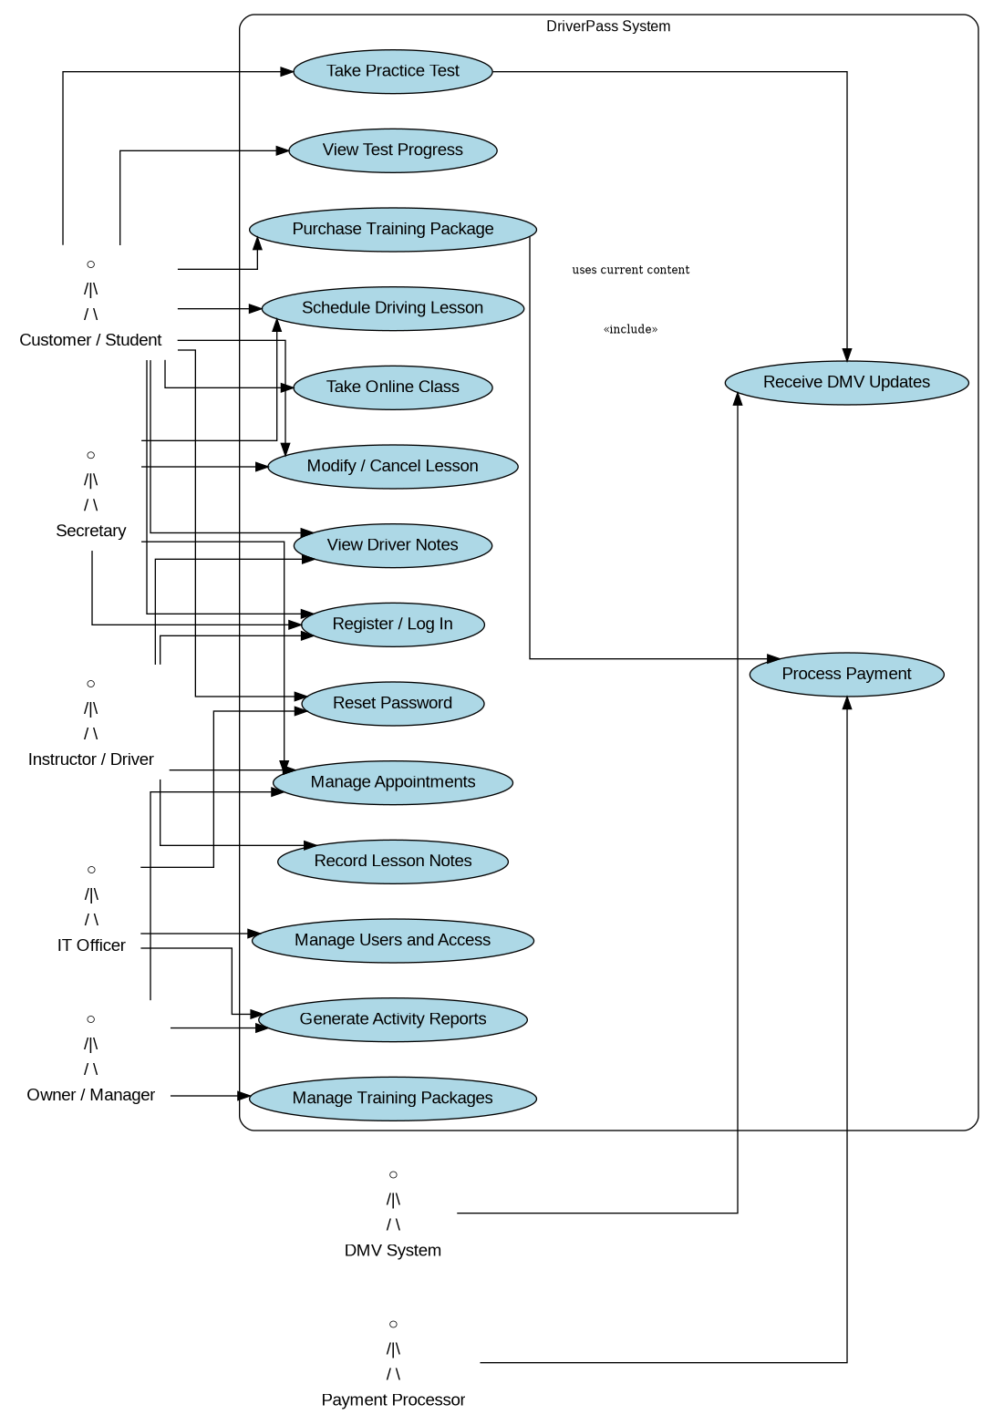
Figure 1. DriverPass UML Use Case Diagram

UML Activity Diagrams
The two activity diagrams below show important DriverPass workflows. The first diagram shows how a customer or secretary schedules a driving lesson. The second diagram shows how a customer takes an online practice test and receives progress results.
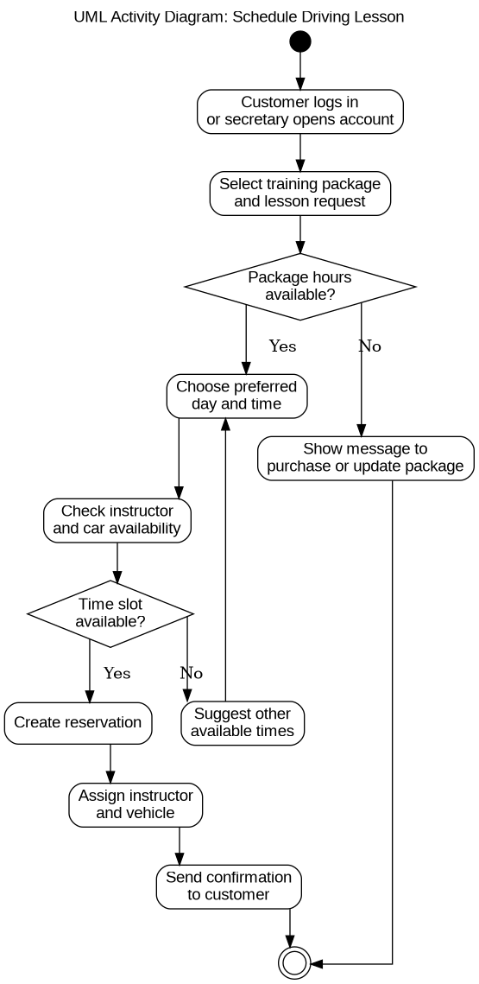
Figure 2. Schedule Driving Lesson Activity Diagram

Second Activity Diagram: Take Practice Test
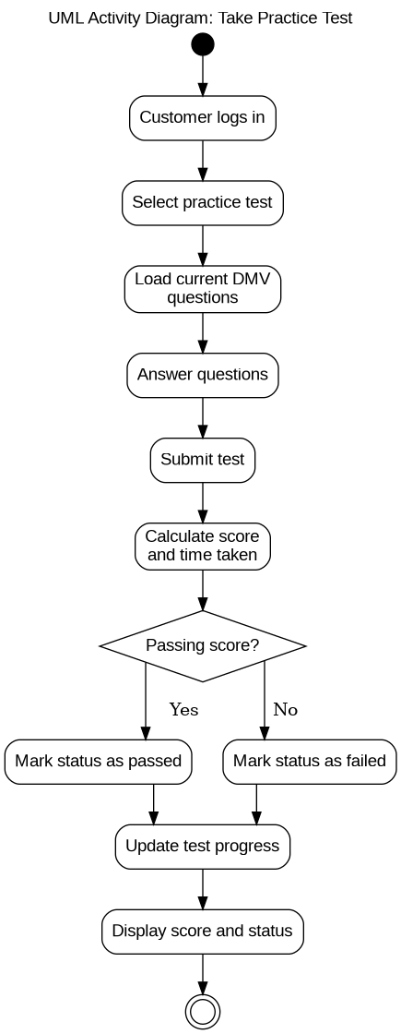
Figure 3. Take Practice Test Activity Diagram

UML Sequence Diagram
The sequence diagram shows how the customer or secretary, DriverPass system, scheduling service, database, and notification service communicate when a driving lesson is scheduled.
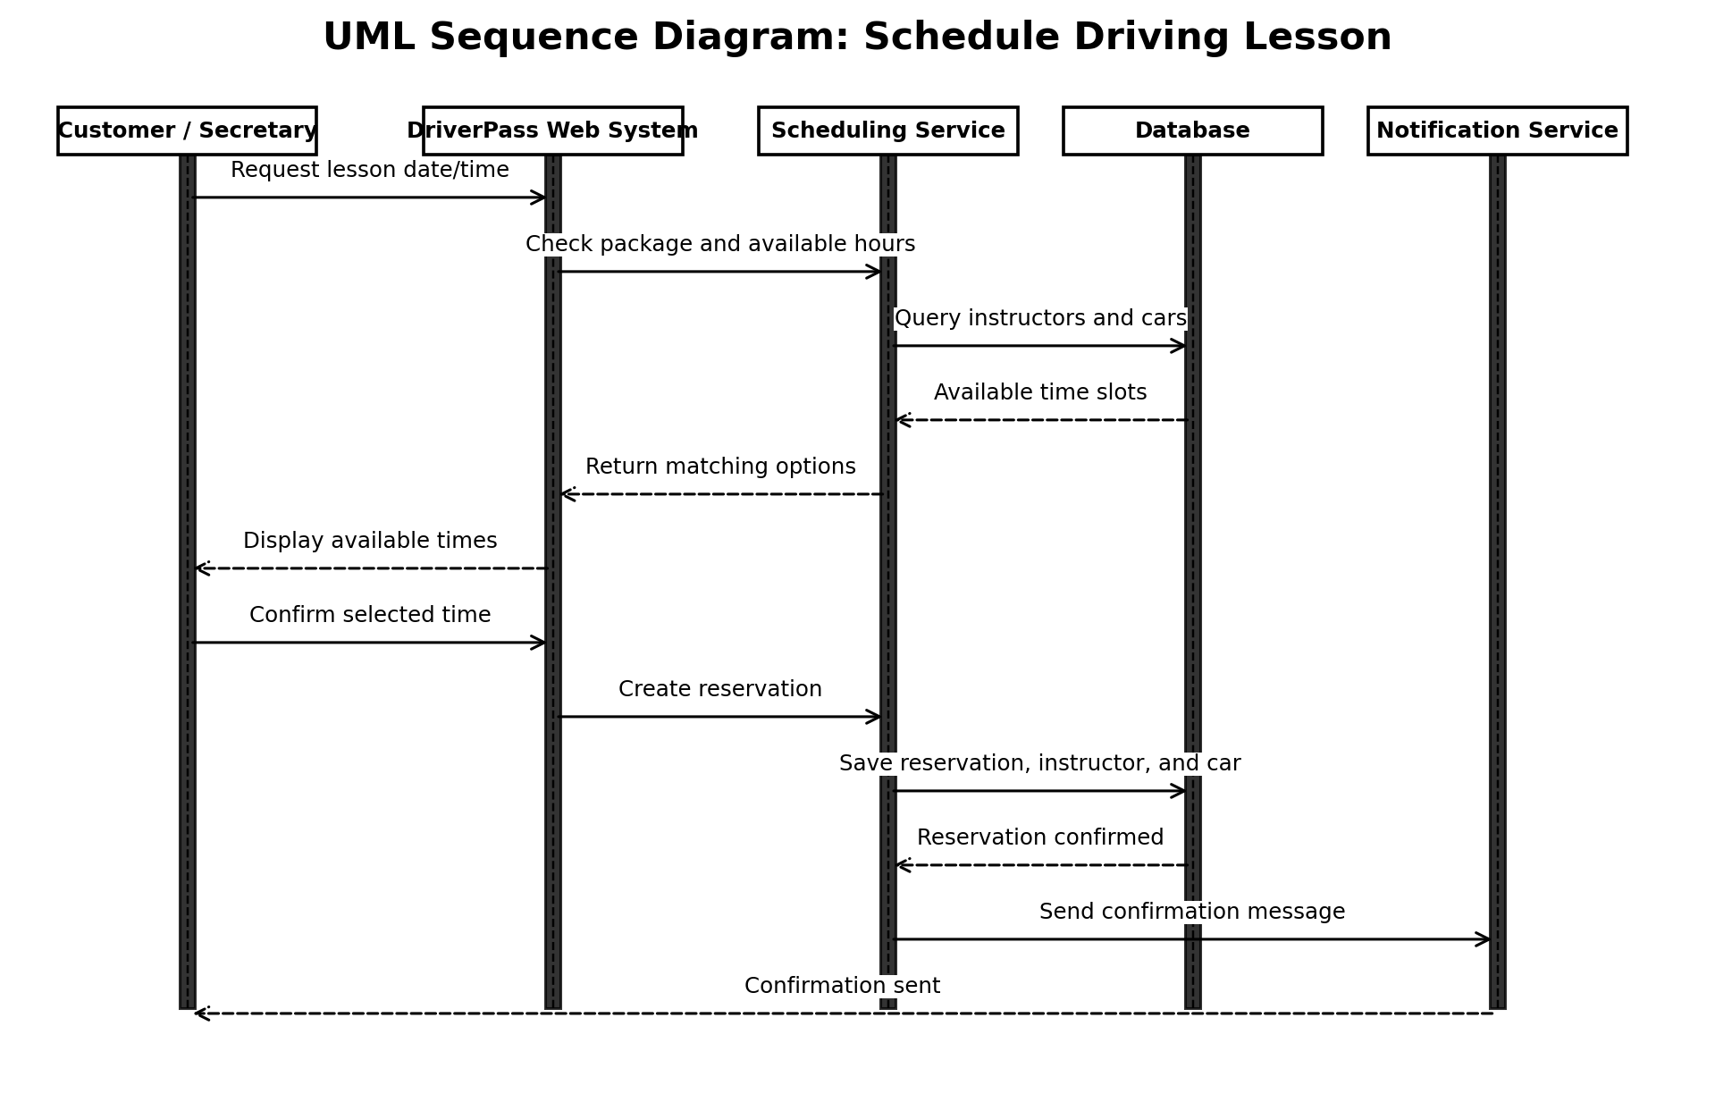
Figure 4. Schedule Driving Lesson Sequence Diagram

UML Class Diagram
The class diagram identifies the main information groups the system must store and connect, including users, customers, instructors, vehicles, reservations, packages, tests, results, payments, activity logs, and DMV updates.
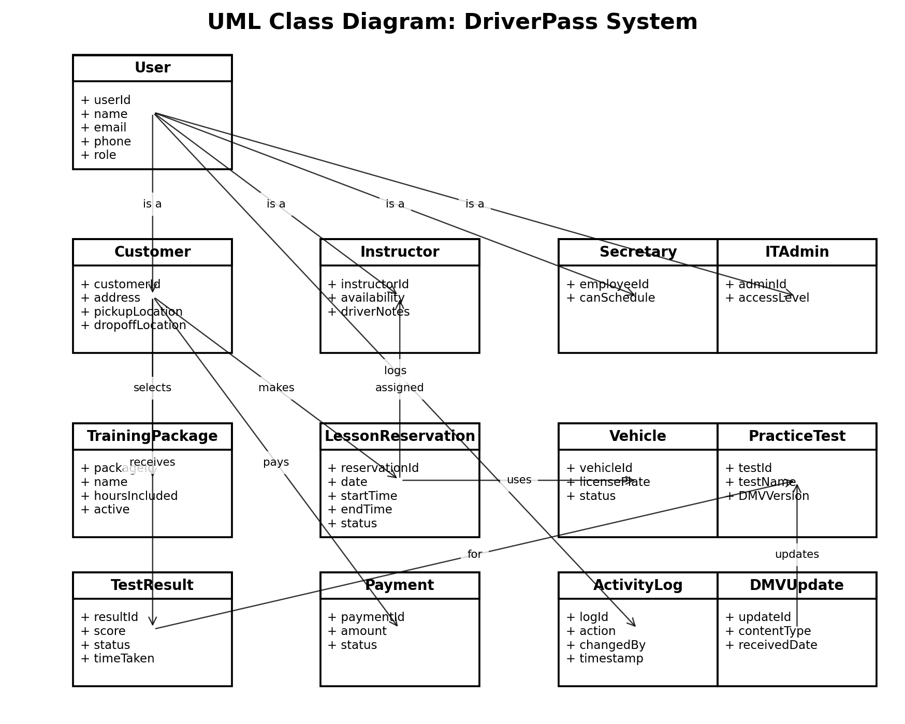
Figure 5. DriverPass UML Class Diagram

Technical Requirements
Technical requirements for the DriverPass system include:
• Hardware: Cloud-hosted web servers, secure database servers, staff computers, instructor/office devices, and customer access through personal computers, tablets, and mobile phones.
• Software: A web-based DriverPass application, secure database management system, browser-based user interface, reporting tools, notification services, and integration support for DMV content updates and payment processing.
• Tools: Development tools for web application development, CASE tools for UML modeling, database design tools, testing tools, monitoring tools, and backup/recovery tools.
• Infrastructure: Reliable cloud hosting, secure network access, encrypted data transmission, role-based access controls, automated backups, disaster recovery, and system monitoring.
• Security: Secure login, password reset, account lockout protection, activity logging, administrative access controls, and protection for personal and payment-related information.
• Performance and availability: The system should be available from modern web browsers on desktops and mobile devices, support multiple users at the same time, and update scheduling information in real time to prevent conflicts.
• Data and reporting: The system must store customer information, lesson reservations, package selections, instructor assignments, car assignments, test results, driver notes, DMV updates, and activity reports.

